NAME | QUANTITY  (pieces) | REFERENCE LINK | REFERENCE IMAGE
Heltec LoRa v3 | 1 | https://pl.aliexpress.com/item/1005004993408849.html | 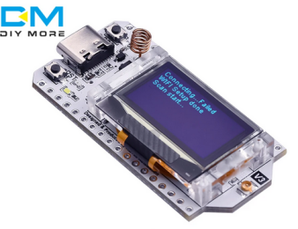
Mx switch  (I’m using brown ones) | 3 | pack of 10:  https://www.amazon.com/Original-Cherry-Switches-Mechanical-Keyboard/dp/B09J3GR5WD?th=1 | 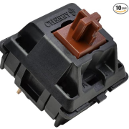
Antena and cable for LoRa  REMEMBER TO ORDER THE RIGHT FREQUENCY FOR YOUR LORA | 1 | https://www.amazon.com/915MHz-LoRa-Antenna-RP-SMA-Wave/dp/B07HZ3BSHM/ | 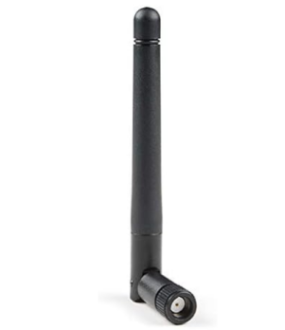
 | 1 | Pack of 2:  https://www.amazon.com/Proxicast-Low-Loss-Coaxial-Bluetooth-Antennas/dp/B09GJGNPQX/ | 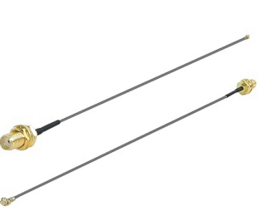
Keycap  Best with numbers from 1 to 3 | 3 | https://www.amazon.com/SparkFun-Electronics-Cherry-MX-Keycap/dp/B082TMSLNQ/ | 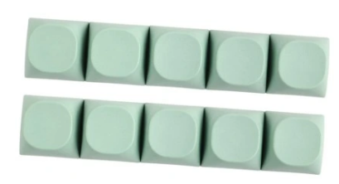
18650 battery cell | 1 | - | 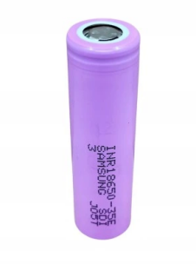
18650 battery holder | 1 | Pack of 10:  https://www.amazon.com/DIANN-10pcs-Battery-Holder-Single/dp/B0BJV7SK5D/ | 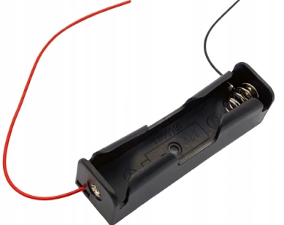
RTC DS1302 | 1 | https://www.amazon.com/RedTagCanada-DS1302-Module-Real-Time-Arduino/dp/B0CQYC3WJH/ | 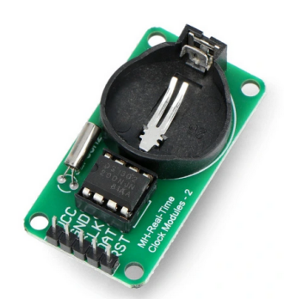
DISCLAIMER:
Links are only for reference and some of them lead to e.g. pack of 20, the real quantity is in a column called the same. If there is quantity of 3 it means that you need 3 pieces e.g. 3 MX switches
CR2032 | 1 | https://www.amazon.com/Duracell-Lithium-Battery-Lasting-Count/dp/B07G7KRQQ5/ | 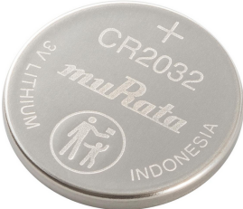
DHT11 temperature and humidity sensor | 1 | https://www.amazon.com/Micro-Traders-16x12-6x6mm-Temperature-Microcontrollers/dp/B0CMSTP1HS/ | 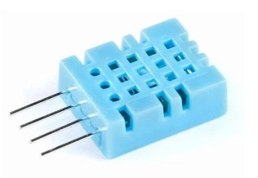
ec11 rotary encoder with button | 1 | https://www.amazon.com/Bolsen-Rotary-Encoder-Digital-Potentiometer/dp/B07HQD627T/ | 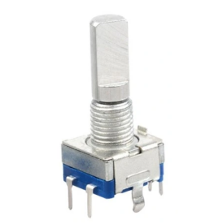
Rocker switch with cutout  size of 13.5x9mm | 1 | https://www.amazon.com/Envistia-Mall-Rocker-Switch-125VAC/dp/B07QFN5Y9K/ | 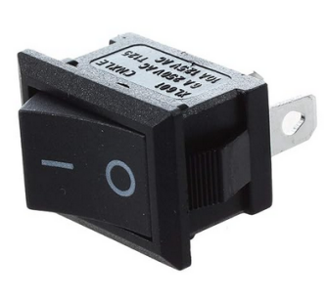
Photo resistor 5-10kOhm | 1 | https://www.amazon.com/a15071300ux0102-Resistor-Light-Dependent-Photoresistor-Optoresistor/dp/B00Q6ZIK1O | 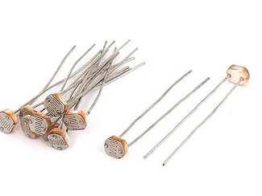
3mm led | 2  (1 red and 1 blue) | Red, pack of 100:  https://www.amazon.com/Diffused-Lighting-Electronics-Components-Emitting/dp/B01C3W6NPS/  Blue, pack of 100:  https://www.amazon.com/Diffused-Lighting-Electronics-Components-Emitting/dp/B01C3ZZT6O/ | 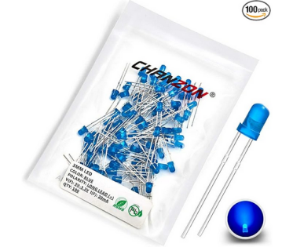
TP4056 | 1 | Pack of 3:  https://www.amazon.com/HiLetgo-Lithium-Charging-Protection-Functions/dp/B07PKND8KG/ | 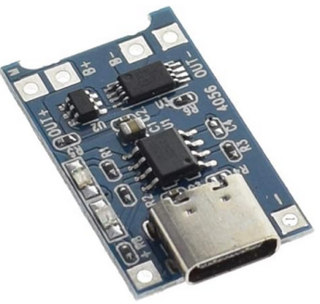
6x6mm push button | 1 | Pack of 20:  https://www.amazon.com/Momentary-Terminal-Pushbutton-Breadboard-Electronic/dp/B09R3ZPWJ7/ | 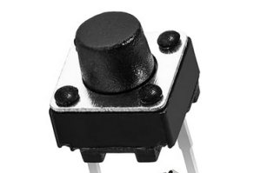
USB C cable  (nothing too fancy, you are gonna cut it anyway) | 1 | https://www.amazon.com/PowerHOOD-Charging-Compatible-Ingenico-MOB55BBBAB-128/dp/B0C8W41D6S/ | 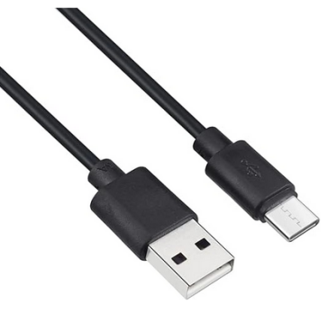
1W/3W led with max diameter of heatsink: 20mm | 1 | https://www.amazon.com/Light-Beads-Bright-Floodlight-5W-Warm/dp/B097S1RG9G/ | 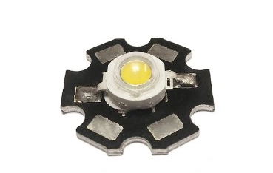
I2C 0.96 inch OLED display | 1 | Pack of 5:  https://www.amazon.com/Hosyond-Display-Self-Luminous-Compatible-Raspberry/dp/B09C5K91H7/ | 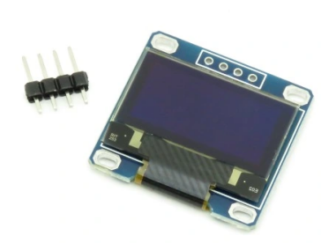
10k resistor | 5 | Pack of 100:  https://www.amazon.com/Projects-100EP51210K0-10k-Resistors-Pack/dp/B0185FIOTA | 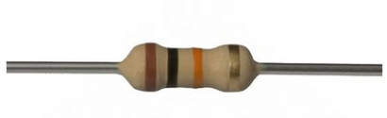
M2 Threaded inserts | 6 | Pack of 100:  https://www.amazon.com/M2x4-0mm-OD3-6mm-Staking-Threaded-Inserts/dp/B08T7NDPQC | 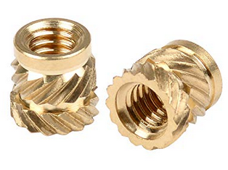
M2x5mm screws | 6 | Pack of 10:  https://www.amazon.com/Deal4GO-10-Pack-Replacement-Phillips-Nickel/dp/B0B3751BM1/ | 